DELPHI WEB STUDIO

Delphi Web Studio User Guide
Illustrated instructions and feature reference
Illustrated edition | Last changed: November 1, 2026
Experimental Windows application
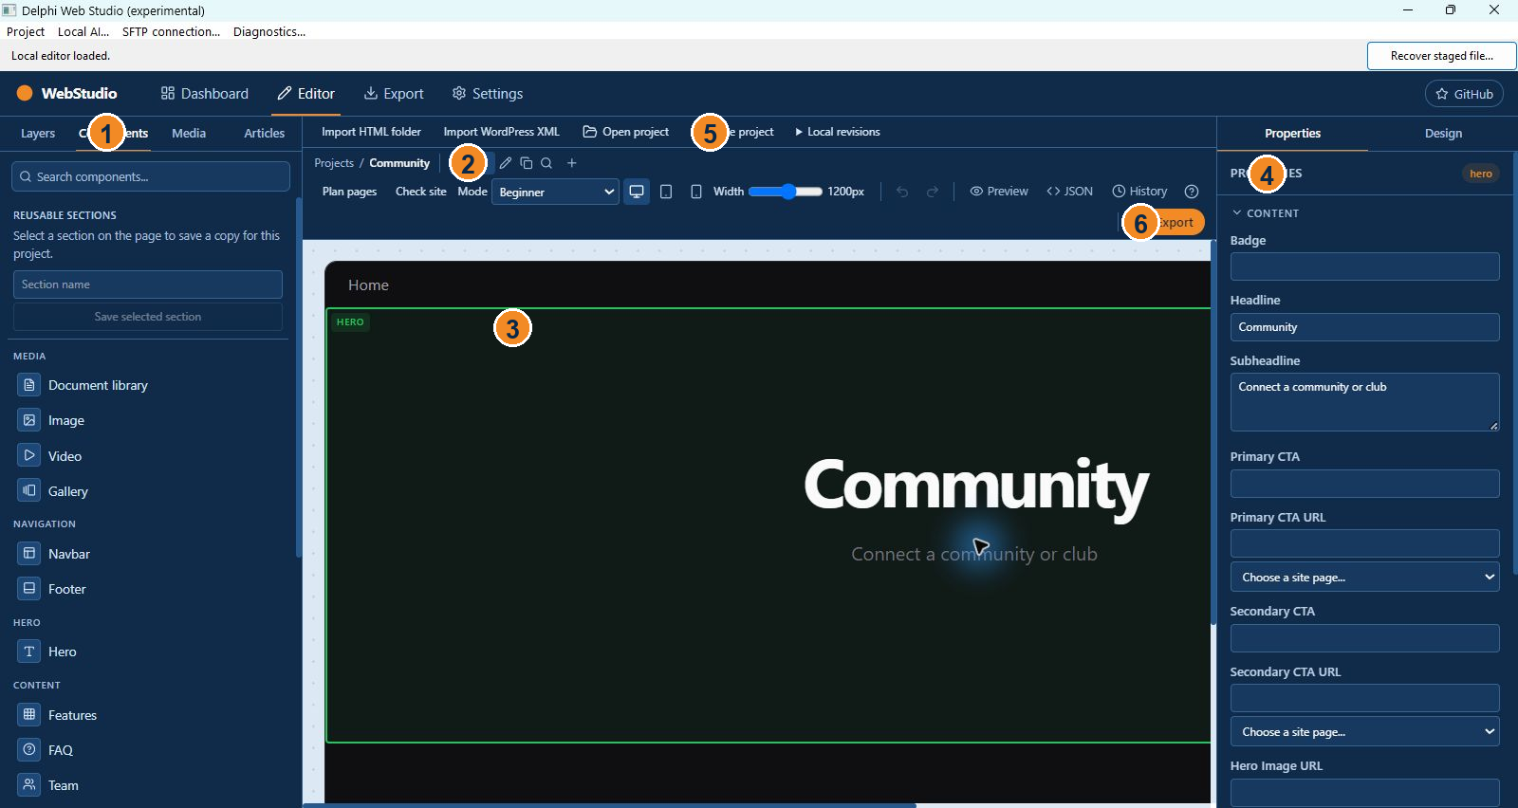
Screens show an isolated example project. Your site content and available options may differ.

Contents
Before you begin 3
Open the program 3
Choose how to begin 4
Create a blank project or starter 4
Open an existing project 4
Understand the editor 4
Build and organize pages 5
Add, edit, reorder and remove sections 6
Add images, documents and PDFs 7
Edit navigation and shared site information 8
Preview and check the site 8
Save and keep recovery copies 9
Import an existing website 10
Optional AI paths 10
Export and review without publishing 10
Work with articles and drafts 11
Change appearance and screen visibility 11
Set links and preserve navigation 12
Use local AI deliberately 12
Use the code panel carefully 13
Understand the desktop menus and status line 14
Privacy and optional online content 14
Worked example A small community website 14
Component reference Common page sections 15
Troubleshooting common workflow problems 16
Review the SFTP tools without publishing 17
Find your way around the dashboard 17
Select and configure a PDF viewer 18
Set up a contact destination 18
Understand the generated website and the editable project 18
Finish and resume later 19
Evidence and limitations 19
Reference Dashboard and project cards 19
Reference Editor layout 19
Reference Page addresses and internal links 20
Reference Section selection and properties 20
Reference Supported section controls 21
Reference Media import and organization 21
Reference Design, responsiveness and accessibility 22
Reference Article authoring and site search 22
Reference Site settings and metadata 23
Reference Local AI and cloud AI 23
Reference File formats, backup and revisions 24
Reference Import limits and retained source 24
Reference Review and export 25
Reference Keyboard controls 25
Reference Known boundaries 25

Before you begin
Delphi Web Studio is an experimental Windows application for creating and exporting informational websites. It combines a Windows window with a local visual editor. This guide follows the work from opening the program through saving a project and reviewing an exported site. The software is not a finished release; a clean Windows installation has not been verified. The site is not published merely by saving or exporting it.
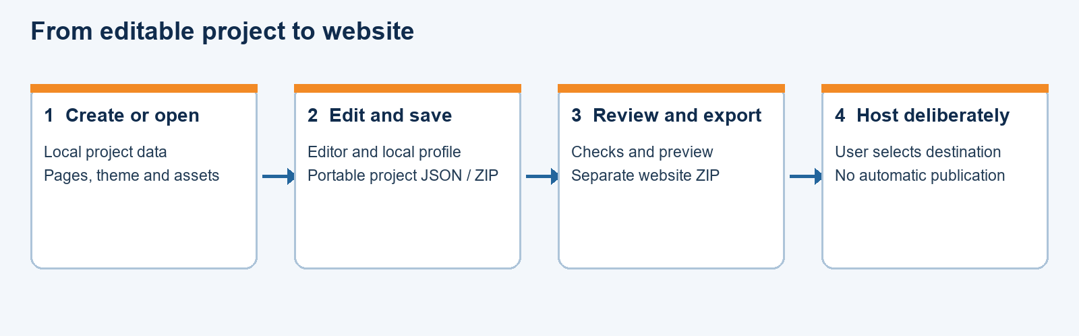
Figure 1. The four stages from creating a project to a deliberate hosting decision.
Use the Win64 build on a 64-bit Windows computer and the Win32 build where a 32-bit executable is needed. Keep the editor folder and WebView2Loader.dll beside the executable. Microsoft Edge WebView2 Runtime must be installed. A project is your editable work; an exported website is a separate set of files intended for a web server. Keep both a project file and independent backups.

Open the program
- Open the desired Win64 or Win32 folder and double-click DelphiWebStudio.exe. The application opens maximized. Wait for the local editor to appear.
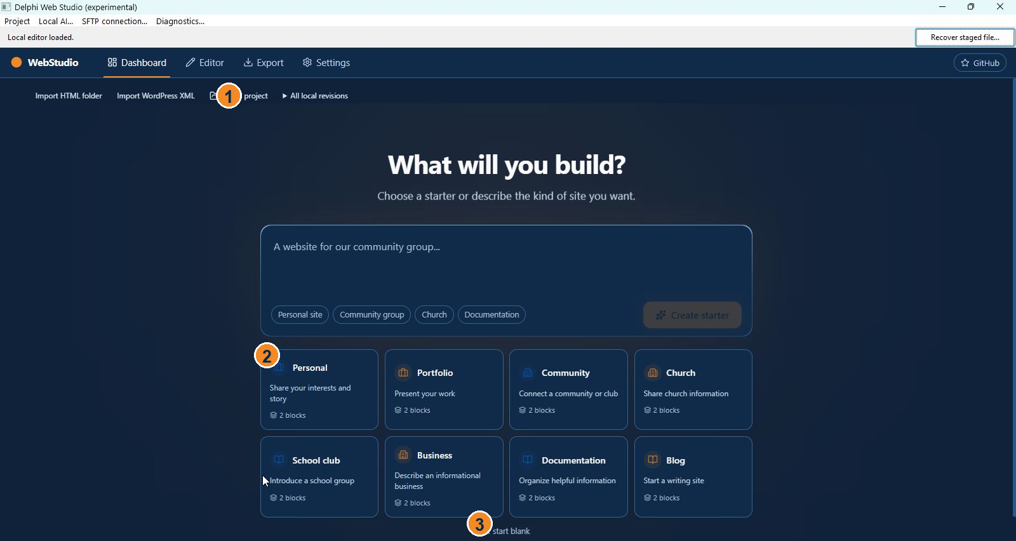
Figure 2. Dashboard: 1 Open project, 2 starter cards, 3 start blank.
- If the editor does not appear, check that the editor folder and architecture-matched WebView2Loader.dll are next to the executable and that the WebView2 Runtime is available. The status line can show startup or save information. Do not delete browser profile data as a troubleshooting step without first saving and backing up projects.
- The dashboard is the starting point. It offers project creation, opening saved projects, importing and local revisions. Existing local drafts appear as cards. Filter and search the cards when there are many projects.

Choose how to begin
There are four principal paths: start blank, choose an editable starter, open an existing WebStudio or OpenPage project, or import supported content from a static HTML folder or a WordPress XML export. Imports create a separate project; they do not modify the source. Preserve the original source and review the import report before relying on the result.

Create a blank project or starter
- On the dashboard choose Start blank for an empty Home page, or choose a starter matching your site, such as personal, portfolio, community, church, school club, business, documentation or blog. Starter text is a prompt for your own content and must be reviewed and replaced.
- Enter or select the requested project information. The dashboard description can select a local starter and is not itself evidence that an AI service generated your site.
- Open the new project in the editor. The breadcrumb shows Projects and the current project; page tabs identify the pages. Home is the initial page.
- Save an initial separate project file before making extensive changes. A local browser draft can help recovery, but it is not a substitute for a project file and separate backup.

Open an existing project
- Choose Open project from the dashboard or editor. Select the WebStudio JSON or project ZIP file, or a supported original OpenPage JSON file.
- The application validates and opens the file as an independent local draft; it does not edit the source file in place. If validation fails, read the message and retain the original. A legacy configuration is converted in memory; save the new project separately.
- Examine the pages and media. Unknown blocks can remain as placeholders; exporting stops if a block cannot be rendered safely. A failed import or interruption may leave staged data in local storage, so keep the original file.

Understand the editor
The central canvas represents the selected page. Use Components to add sections and Layers to select or reorder existing sections. Select a section to show its editable properties. Use Design to change the theme. Media holds imported project files. The editor toolbar includes page tabs, Plan pages, Check site, Mode, viewport controls, undo, redo, Preview, JSON, History, keyboard shortcuts and Export.
Figure 3. Editor: 1 Components, 2 page tabs, 3 canvas, 4 Properties, 5 Save project, 6 Export.
Beginner, Designer and Professional are different starting arrangements for the same project. Professional opens the JSON view; it is not a full direct editor for all generated HTML. The application can also store additive page-specific custom code, but desktop custom-code preview is limited. Use trusted code and test the exported result.

Build and organize pages
- Select a page tab to work on that page. Use the plus button titled Add page to provide a page name and path. Paths must be valid and unique; the Home path remains /.
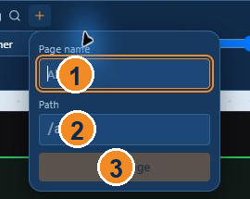
Figure 4. Add page: 1 page name, 2 path, 3 Add Page. The example shows placeholders.
- Use the page tab controls to rename a page, change its address, edit its search title and description, duplicate it, or request deletion. Deletion is confirmed and cannot remove Home as the last page.
- When changing a path, use the offered option to update supported internal links. Links outside the supported set and external bookmarks are not all rewritten. Review the resulting links.
- Before deleting a page, read the list of known references. Deleting a page does not automatically remove every link to it. Undo is available during the editing session, but does not replace a saved backup.
- Plan pages offers a manual choice of common pages such as About, News, Events and Contact. Review the proposed pages and explicitly accept or cancel. This command is not itself an AI request.

Add, edit, reorder and remove sections
- Open Components and click a section to add it at the end of the current page, or drag it to a position above or below another section.
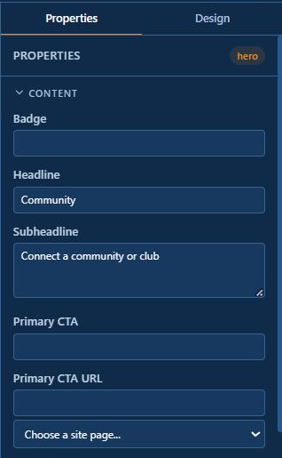
Figure 5. A selected Hero exposes its editable fields in Properties.
- Select the section on the canvas or in Layers. Change the available text, links, images, style and other fields in Properties. The fields vary by section and layout. For example, a Hero can have a headline and destination, while a PDF Viewer has document and viewer controls.
- Use Layers to reorder or remove sections. Confirm any requested deletion and use Undo if the result is not what you intended. Review every page after structural changes.
- In a Content section, select text in the Body field and use Bold, Italic, Heading or List. Insert a page or media link with the corresponding control. These are formatting markers in the editing field and are rendered in the preview and export.
- You can save a selected section as a reusable section, then insert an independent copy elsewhere. Shared Navbar and Footer sections are a separate feature: changes to a shared section can propagate across pages. Stop sharing when independent copies are needed.

Add images, documents and PDFs
- Open Media and import individual files or folders, or drop them from Explorer. Select the duplicate policy: reuse an existing matching item, keep a separate copy, or skip the duplicate. The app reports rejected files; source files are not modified.
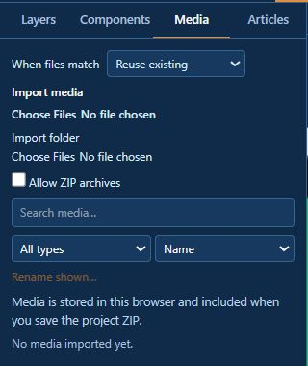
Figure 6. The Media panel provides duplicate handling, file and folder import, and search.
- Wait for the import report. Imports can be cancelled, and a cancelled batch can be resumed while the application remains open. A pending list is not retained after the app closes.
- Find a file using the library search, filters and sort controls. Rename the displayed item or replace it as needed; supported operations offer undo. Confirm the result before discarding your original files.
- Select an image-capable section and use its chooser to select an imported image. For a PDF, add a PDF Viewer section and select the document. Set the title, caption, starting page, fit mode and available viewer controls. A document library can list files with titles and descriptions.
- Hidden download or print controls do not make a PDF private on a public website. Text search depends on searchable text; a scanned image PDF is not automatically converted to text.

Edit navigation and shared site information
Select a Navbar or Footer section and add navigation destinations in its properties. Choose a site page where the chooser is available, or enter an appropriate external address. Older text-only labels are preserved but are not automatically converted into links. Check the links in the exported site. Set the site name, description, optional favicon URL, search, language and SEO information in Settings. Optional public site URL affects canonical addresses and sitemap output; include any intended subfolder.
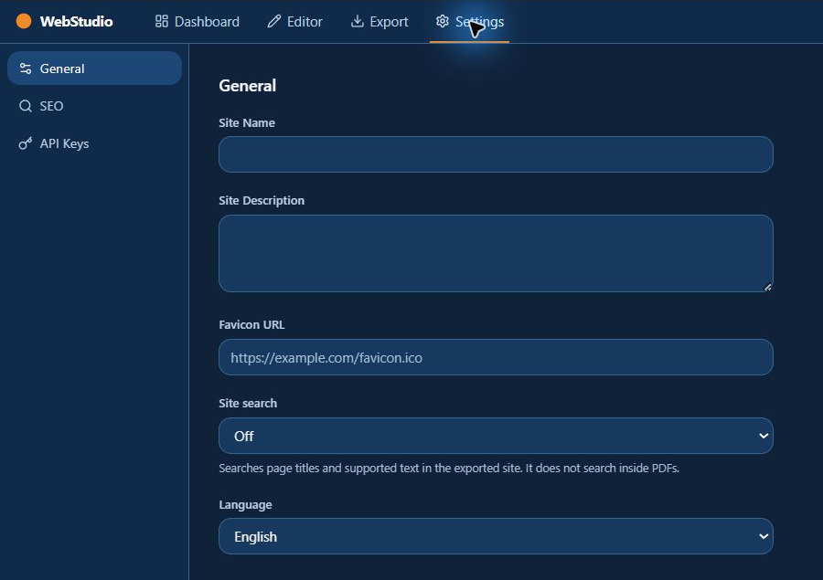
Figure 7. General settings for the site name, description, search and language.

Preview and check the site
- Choose Desktop, Tablet or Mobile in the toolbar, or adjust Width. These are simulated widths; they are not a substitute for testing in actual browsers and devices.
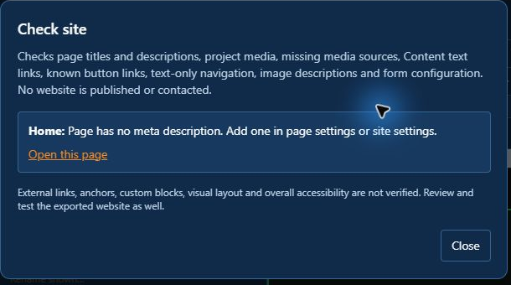
Figure 8. Check site reports selected issues and states the limits of its checks.
- Use Preview to see the current page without normal editing controls. Return to editing when finished. Check long text, image placement, page links, mobile layout and each PDF.
- Choose Check site and review its reported issues. Fix applicable links, missing files, empty content, SEO and unconfigured forms. The checker is useful but is not a complete audit of every possible site.
- Contact forms and newsletter blocks require an appropriate configured service to work. The optional email-draft action opens the visitor's email application; it does not silently submit a message for them.

Save and keep recovery copies
- Choose Save project, select a folder and filename, and wait for completion. Projects without media can be JSON; projects with media use a ZIP containing the manifest and media. Do not confuse this project ZIP with the exported website ZIP.
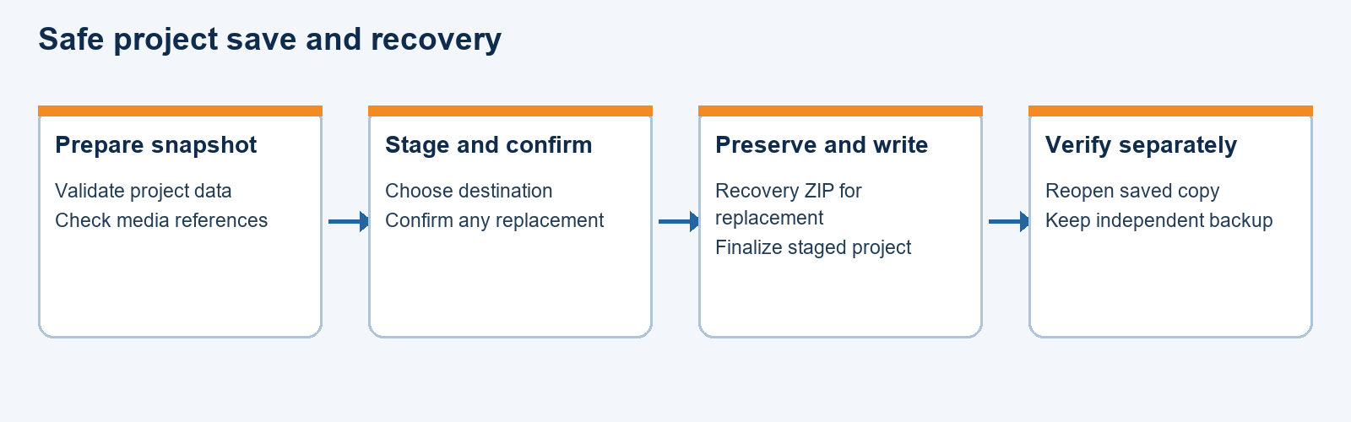
Figure 9. A project save and a separately verified backup are distinct steps.
- If replacing an existing project, read the separate confirmation. The desktop save flow creates and verifies a recovery ZIP before replacement. Failure messages may point to a staged or recovery file; preserve it and inspect it rather than deleting it.
- If edits occur while a snapshot is being prepared, the saved file can reflect the earlier snapshot. Follow any prompt to save again. Reopen a saved copy to confirm the pages and media.
- Use Create local revision to make an additional local snapshot, and All local revisions to inspect available revisions. They reside in local app storage, are not automatically synchronized or included in exported project files, and can be lost with the profile or storage. Save important revisions as separate files.
- Project backup and restore controls can create a checked backup ZIP and restore to a new filename. Keep independent copies on another drive and test reopening them. Recovery does not guarantee protection against all hardware or power failures.

Import an existing website
For a static folder choose Import HTML folder, select the folder, read the report and choose Create HTML project. Basic headings, text, supported links and images may be converted. Layout, styling, scripts, complex markup and some references are not reconstructed. The original HTML and CSS can be retained as inactive project data; read-only unconverted source blocks are excluded from website export. Keep the source folder and check each page.
For WordPress choose Import WordPress XML, select a supported WXR export, read the report and choose Create imported project. Posts and pages are converted to editable content with limitations. Images and attachments require separate attention; themes, plugins, shortcodes and server features are not recreated. Posts and unpublished pages start as drafts. The source XML and report may contain private information and can be included when the project is shared. Inspect imported source through the JSON panel.

Optional AI paths
Local page planning and local starter selection work without a Google key. The optional local AI planner requires separately configured compatible runtime and model files; review its proposed changes before accepting. Generated text can contain unsupported claims and needs human checking.
Cloud generation is optional and must be enabled for the session in Settings > API Keys. A generation brief can be sent to Google or a configured server. A newly entered Gemini key is kept in memory only until the app closes or reloads, so it must be entered again for a later session. Older previously stored keys may remain in local storage until removed with the displayed control. Testing a key requires an internet connection. Do not include secrets in site content or project files.

Export and review without publishing
- Save the project first. Choose Export in the editor, wait for preparation, and select a destination for the website ZIP. Export is separate from saving the editable project and does not itself publish the site.
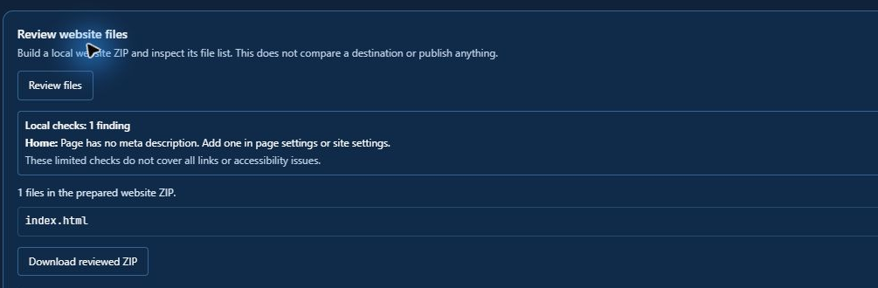
Figure 10. Review website files builds a local list and does not publish the site.
- Extract the ZIP into a separate test folder. Inspect the generated pages, navigation, images, PDF files and any reports. A local web server may be needed for the bundled PDF viewer because browsers can restrict modules opened directly from a file address.
- Check the site at desktop and mobile widths, follow links, examine accessibility and replace placeholder content. User-supplied external images, video and other URLs may need internet access. Test the site on the intended host before treating it as ready.
- The application includes an experimental SFTP review and transfer workflow. Transfers require deliberate destination review and explicit confirmation; real-host deployment has not been verified in the recorded tests. A partially failed transfer can require recovery. Do not start a transfer until the destination and backups have been reviewed.

Work with articles and drafts
- Select a non-Home page and open the Articles tab. Choose Make this page an article. The page name and path serve as its title and address. Enter an author, summary and optional tags. Creation and modification timestamps are stored automatically. These fields do not establish a public author account or a permissions system.
- Keep unfinished articles in draft status. Draft articles are excluded from the generated site and page chooser until marked ready. Changing an imported WordPress page to ready can also cause it to appear in the generated article index, so inspect the result.
- If you use the optional article index or RSS output, enter and check the appropriate site settings. RSS and search are generated from the information available at export. A static site does not automatically publish a scheduled article at a future time without an external process.

Change appearance and screen visibility
- Select Design to adjust the available theme colors and typography. A theme changes a shared appearance setting; check more than the currently visible page to see its effect.
- Select a section and inspect its available Style or Variant controls. Different sections offer different arrangements. A property that applies to one section may not exist on another.
- Use screen visibility properties when a section should appear only at particular widths. A hidden section is still in the exported HTML and must not be used to conceal confidential information. Preview mobile, tablet and desktop after changing visibility.
- Click the device buttons or move the Width slider. The preview width can be wider than the editor window; use the horizontal scrollbar to inspect the remainder. A real phone or browser can still behave differently.

Set links and preserve navigation
- For a button, Hero, call to action, Navbar or Footer, select the section and find the appropriate destination field. Use the page chooser where offered, or enter a valid external address. Selecting a page fills its current path.
- For an inline link, select the text in a Content section and use the page or media link control. If no text is selected for a page link, the chosen page name becomes the label. Edit the label if necessary.
- After renaming a page path or deleting a page, run Check site and manually follow important links. The app checks known link locations, not every custom block, script or external bookmark.
- When building a shared header or footer, first remove a competing section where necessary, then choose Share across pages. New pages receive the shared section. Stopping sharing leaves separate copies that can be edited independently.

Use local AI deliberately
- Open a project and choose Local AI from the Windows menu. Use Browse to select the supported llama.cpp b12012 Windows x64 CPU runtime ZIP and a supported GGUF model file. The buttons open download links in your browser; afterwards, select the downloaded files with Browse. The runtime and models are not included automatically with the editor. The offered runtime is x64, so it requires a 64-bit Windows system even when using the Win32 editor. Five-page planning requires a blank project; the other offered actions work on existing projects.
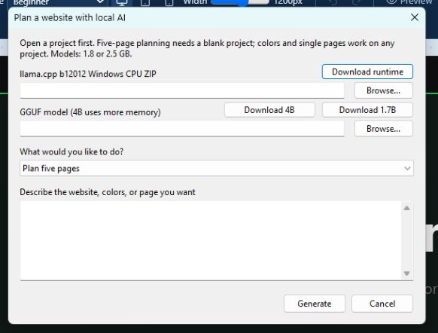
Figure 11. The optional local AI dialog selects a runtime ZIP, model and proposal type.
- Supply a brief in the supported planning workflow. Review the proposed page names, content and any supported theme changes before accepting. The local action system supports a limited set of structured changes, not unrestricted editing or arbitrary code execution.
- If the project changes during review, request a fresh proposal. Accepted changes are applied as an undoable edit. Check facts, contact information, descriptions and links yourself; generated language may invent details.
- The application manages the local inference process for its request. A model that works on one computer may use more memory or behave differently on another; no general hardware performance guarantee has been established.

Use the code panel carefully
- Choose JSON on the editor toolbar or press J to open the code panel. The editable JSON represents project data. Inspect page HTML provides a read-only generated snapshot rather than unrestricted direct editing of the exported file.
- If you edit JSON, validate and apply it using the controls shown. An invalid draft is rejected. If the active project changes while the draft is open, application may be blocked; copy your draft before closing if you need to preserve it.
- Inspect imported source displays retained HTML, CSS, WordPress XML or import reports as text. Inspecting them does not execute the content. Retained files can contain personal or private data; review the project before sharing it.
- Page-specific custom HTML, CSS and JavaScript are additive. Desktop preview does not execute the custom-code frame; inspect the exported site separately. Only use code you trust, since exported code can run in a visitor's browser.

Understand the desktop menus and status line
The native Project menu contains backup and restore operations in addition to the editor's own project commands. Recover staged file selects a temporary project download and moves it to a new filename in the same folder after a basic format check. A staged file may be incomplete: reopen it and check the content before relying on it. Recovery does not overwrite an existing destination.
The status line reports startup, download or save progress. If a project save is interrupted or finalization fails, its hint can identify a staged file. A completion message reflects the operation's reported result; verify your saved project, and maintain an independent backup.

Privacy and optional online content
The editor stores local drafts, settings, media and revisions in the WebView profile. Clearing that profile can remove working data. A project ZIP may contain imported source and media, including information not visible on exported pages. Inspect the project before sharing it.
External images, video services, optional analytics and optional cloud AI can contact outside services. Local project editing and local export do not require publication. Review the destination, credentials and information sent whenever you choose an online feature.

Worked example A small community website
This example uses fictional information. Replace the names, wording, addresses and images with information you have permission to publish. The example ends with a local export; it does not upload the site.
- Open the dashboard and choose the Community starter. The editor opens with a Home page and editable starter sections. Return to Projects when needed; the project card can be renamed with its pencil button. Project name and public site name are separate values.
- Select the Home page Hero. In Properties, replace Headline and Subheadline with your own text. Edit the Primary CTA label and destination or clear them if the button is not needed. Choose a Hero layout from the available variants. A selected Hero image is displayed in the split layout.
- Choose Add page, enter About and a unique path such as /about, and add it. Select Components, add a Content section, then select the new section and type the organization's real description. Use Bold, Heading or List on selected text as needed.
- Add a News page. Open Articles and choose Make this page an article if it represents one article. Enter an author and summary. Leave it Draft while writing, and mark it Ready only when it should appear in the next export. For several articles, create separate non-Home pages.
- Add a Documents page. Open Media, choose the community's bulletin PDF and import it. Add a PDF Viewer section to Documents and choose the imported bulletin. Enter a useful title and accessibility label, test the preview and set Mobile display if a link is preferred on small screens.
- Add a Contact page with a Content section containing ordinary contact details. A contact form needs a configured HTTPS service or the supported email-draft option; merely placing a Contact section does not guarantee that messages will be delivered. Do not invent an email address or service endpoint.
- Select the Navbar and add destinations to About, News, Documents and Contact using the page chooser. Draft articles are omitted from the chooser. Inspect the Footer, enter your chosen copyright or attribution, and add only links you actually want. Share the header or footer across pages if appropriate.
- Open Settings > General to enter the public site name and description. In SEO, provide a page title and description. Leave the public site URL empty until the destination is known; the field can later include an appropriate site subfolder.
- Save the project to a new file. With imported media, expect a WebStudio project ZIP containing the manifest and media. Reopen a separate copy and check that the pages, links and PDF are present. Keep a second copy on another drive.
- Check site, resolve the issues you understand, and inspect every page at mobile, tablet and desktop widths. Use Export to create a separate website ZIP. Extract it in a test folder and review it locally, using a local web server when needed for the PDF viewer. No public website has been created by these steps.

Component reference Common page sections
The list below describes editable controls visible in the current source. The available choices depend on the section selected. New empty repeated-item sections need your own entries; they should not be mistaken for finished content.
Navbar: enter Logo Text or choose a logo image, add a CTA Button label and CTA Destination if desired, and manage Navigation destinations. The default and centered variants arrange the header differently. Legacy text-only labels are preserved as labels rather than silently made into links.
Hero: enter Badge, Headline, Subheadline, primary and secondary call-to-action labels and their destinations. Variants are centered, split, gradient and minimal. A hero image chooser is available; the documented split layout uses it. Check a button destination after changing page paths.
Features: provide Section Label, Title and Subtitle, then add or edit Feature Cards. Choose grid, list or alternating layout. Add truthful descriptions and choose images where offered. Items start empty in new sections.
CTA: supply Headline, Subheadline, Button Text and Button URL. The simple and split variants change the arrangement. A call to action is an ordinary link; the app does not promise the destination exists.
Footer: enter Logo Text, logo image, Description and Copyright, and add Navigation destinations. Simple, multi-column and minimal variants present different layouts; the minimal layout does not display the logo. The copyright field can contain your own author or organization credit.
Testimonials, Stats and FAQ: enter titles or subtitles and add your own testimonial entries, statistic entries or questions and answers. Testimonial variants include cards, carousel and spotlight; statistics include grid, bar and counter. Verify all claims and do not leave invented endorsements or figures.
Team and Logo Cloud: add your own member information or logo labels in their item controls. Image selection is available for team members where offered. Obtain permission to use names, portraits and marks.
Content: type or paste text in Body and select prose, columns or highlight style. Select text before applying the available formatting buttons. Use the page-link or media-link controls to insert references, then verify the exported destinations.
Image and Gallery: choose an image from Media or use a suitable URL, provide meaningful Alt Text, and enter optional title or subtitle. Image offers hero-image, side-by-side and grid variants; Gallery offers grid and masonry. An external URL may require a network connection and can stop working if its owner removes it.
Video: enter a supported YouTube or Vimeo address, a title and the appropriate platform selection. Playback depends on that service and its network and privacy settings. Check site can flag unsupported address formats, but does not prove that a video exists or will play.
Divider and Banner: use Divider to add a line, space or dots, with a width and height. Banner provides text, link text and a destination, with ribbon or bar styling. Check that a banner's destination remains valid.
Contact and Newsletter: enter the available title and descriptive text. Contact can use a service HTTPS URL, consent notice and contact email where configured. Newsletter has content and button wording, but adding it alone does not connect a mailing-list provider. Review privacy notices and verify the actual destination and service separately.
Document, Document library, Audio, local video and PDF Viewer: select an appropriate media item and edit the properties supplied for the section. Document library items have titles and descriptions and can be filtered by those values; it does not search the contents of the underlying documents. PDF Viewer has separate page, fit, search, thumbnail, download, print, fullscreen and mobile choices.

Troubleshooting common workflow problems
The project is missing from the dashboard: check the project filter and search text first. Drafts and revisions are tied to the local WebView profile. If you saved a separate project file, use Open project to create an independent draft from it. Do not clear local storage before recovering needed work.
The app rejects a project: read the message, keep the source file unchanged and check its format and version. Unsupported blocks are retained where possible; a website export can be stopped instead of silently dropping content. A malformed ZIP, invalid path, duplicate identity or invalid UTF-8 can prevent opening.
An imported page looks different: the importers convert only supported content. Examine the import report and retained source. Layout, plugins, styling, scripts, attachments or unrecognized links may need manual rebuilding. Compare with the original and retain it as your reference.
A file or PDF does not show: check that it was imported to the current project's Media library and selected in the section. Verify any reported checksum or missing-media warning. If the exported PDF viewer does not run from a file address, test the extracted site through a local web server. A network-hosted video requires its external provider.
An export stops: read the reported page, missing media, unsupported block, conflicting filename or link. Correct the identified item and export again. Save the editable project separately before experimenting. Check site does not verify all external links, custom code, visual layouts or overall accessibility.
A save was interrupted: keep the original and any recovery ZIP. Inspect the status for the staged path; use Recover staged file only to create a new name, then open the result and inspect it. If recovery fails, use a verified earlier copy. Do not assume that a temporary file contains a complete project.

Review the SFTP tools without publishing
The SFTP connection window accepts a host, username, port, private key and trusted-hosts file. A correct host-key entry helps identify the server. Treat the private key as confidential. Test connection is a separate operation from uploading; Scan destination and Back up destination prepare review data. The source shows limits of 512 MiB per scan or backup and 64 MiB per backed-up file, with links unsupported.
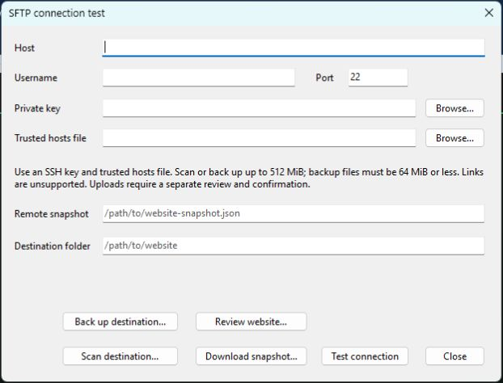
Figure 12. The SFTP dialog separates connection, scan, backup and review actions.
Review website opens a separate review window where you can select the website ZIP, destination scan, backup ZIP and other recovery information. Review files compares local inputs; Check destination checks the entered destination separately. The Publish button is a further deliberate step that asks for confirmation. Do not use it until you actually intend to upload. A failed or interrupted transfer can leave partial changes; keep and inspect the receipt and recovery materials.
The recorded SFTP tests used synthetic loopback data. Actual hosting and rollback have not been verified for your site. A recovery folder must be outside the public website and not served by the host; the application cannot establish server configuration for you. Saving a project, exporting a ZIP, reviewing files and testing a connection do not themselves publish a site.

Find your way around the dashboard
Choose or type a description and use Create starter, or select one of the starter cards. The description is matched to a local template. The cards under Your projects represent local drafts; click one to open it. Hovering or focusing a card exposes controls to duplicate, rename or remove a project. Duplicate creates a separate draft and copies its media. Removing a card requires confirmation, and the temporary Undo notification is available only briefly; it is not a permanent backup.
The dashboard search filters projects by name, and All, Published and Drafts filter the displayed cards. A status indicator is not proof that files currently exist or are publicly reachable on a hosting provider. Use Open project for a saved JSON or ZIP, and All local revisions to inspect snapshots even when a project card has been removed.

Select and configure a PDF viewer
Import the PDF into Media first. Add a PDF Viewer section to the intended page, select it and choose the PDF from the project library. Set its title, caption, accessibility label, height and starting page in Properties. Auto fit, width and page fit determine how much of a page appears; zooming in may require scrolling.
Choose which thumbnail, search, print, download and fullscreen controls to show. A mobile link is an alternative to the embedded viewer on narrow screens. Search looks for text present in the PDF; a scanned image without a text layer cannot be searched this way. Even if the download control is hidden, an exported public PDF can still be retrieved by visitors.
Preview the document in the editor, save the project and reopen it, then export a site ZIP and test the viewer from a local web server. The editor and exported viewer are not identical. Large, encrypted or unusual PDFs and all browsers have not been exhaustively verified.

Set up a contact destination
Select a Contact section and enter the title and any explanatory text. If you intend to use an external service, enter its HTTPS form endpoint and an appropriate privacy or consent notice, then configure and test that service independently. If using the optional email draft behavior, provide the recipient as instructed; the visitor's own email application opens and the visitor must send the message.
Neither option is a built-in mail server or proof that delivery has succeeded. Until an appropriate destination is configured and tested, treat the form as unconnected. Review your host's and provider's requirements before making the site public.

Understand the generated website and the editable project
The project file contains the information the editor needs to reopen your work. Save it whenever you need an editable version. Media-free projects may be JSON; projects with media are saved as a ZIP. A project may contain drafts, retained imported source, local references and private information that should not necessarily be shared with site visitors.
The website ZIP contains generated pages and supported assets for the exported site. It does not contain the full editing environment, and changes made directly to its extracted HTML are not automatically reflected in the project. Draft article pages are omitted. Exporting again creates a new snapshot; it does not update a remote host automatically.
Do not delete the project after exporting. Keep distinct names for the project ZIP, website ZIP and backup ZIP, and reopen the project to confirm it before relying on any one copy. An exported website is not an automatic backup of all editable project data.

Finish and resume later
Save the project and verify the file exists in the folder you chose. Keep the project file, exported ZIP and independent backups clearly named. Close the application when no save is in progress. To resume, reopen the project file or a local draft, check the pages and media, and save a new copy as work progresses. Publishing is a separate, deliberate action and is not required to use or inspect the editor.

Evidence and limitations
This guide describes the source and recorded tests available on November 1, 2026. Main sources include src/routes/Dashboard.tsx, src/editor/CanvasToolbar.tsx, src/editor/PropertiesPanel.tsx, src/routes/Settings.tsx, desktop/DelphiWebStudio/WebStudio.Main.pas, docs/PROJECT_FILES.md, docs/EDITOR_EXPERIENCE.md, docs/MEDIA_LIBRARY.md, docs/AI_ACTIONS.md, docs/STATIC_HTML_IMPORT.md, docs/WORDPRESS_IMPORT.md and docs/M8_VALIDATION.md. Some individual workflows have been tested with synthetic samples, not every site or failure condition. Clean-Windows testing, broader accessibility, redistribution review and real-host publication remain unverified.

Reference Dashboard and project cards
The dashboard begins with What will you build. Enter a short description and choose Create starter, click one of the eight named starter cards, or choose or start blank. These routes use local starter content. A blank project initially has the local name Untitled Project and an empty Home page. A starter can contain editable sample prompts; replace them with information you want on the site. This process does not require an account or an AI key.
Your projects shows locally stored project cards. Clicking a card opens that local draft. Use the pencil on a card to rename it, the duplicate control to create an independent local copy with media, or the delete control and its confirmation to remove the card. Deletion has a short-lived undo notice; the notice expires. A local revision can remain available after the associated card is removed. Neither a card nor a revision replaces a saved project file.
Project filters are All, Published and Drafts. Search matches project names. A card's status is stored app information; it does not establish that a remote website currently exists. Use the project file commands near the dashboard top to open a saved project, import a supported site or inspect local revisions.

Reference Editor layout
The editor's project-file row is separate from the page and editing toolbar. Open project reads a supported file into a separate draft. Save project prepares a portable project snapshot. Local revision commands manage additional snapshots in the local profile. Import HTML folder and Import WordPress XML start conversion into another project.
The toolbar starts with the Projects breadcrumb and current project name, followed by the page tabs. Select a page before editing its sections. The plus control adds a page. Page-tab controls allow supported operations including rename, path and search metadata editing, duplication and deletion. The Home page has the root path / and is protected from removal as Home.
Plan pages is a manual planning dialog. Check site examines supported project content. Mode selects Beginner, Designer or Professional. The device icons and Width slider change the simulated preview width. Undo and Redo operate on supported editor changes; History shows the current editing history. Preview changes the presentation of the canvas. JSON opens the code panel. The question-mark control opens keyboard help. Export creates website output, not a saved project.
Panels are selected in the editor. Components lists sections available to add. Layers lists sections on the selected page so they can be selected and reordered. Properties changes fields for the selected section. Design exposes theme settings. Media manages local assets. Articles manages the selected non-Home article page. The available controls depend on the active page and selection; a disabled or absent control should not be assumed to work in all contexts.

Reference Page addresses and internal links
When adding a page, give it a nonempty name and valid unique path. The project validator rejects duplicate paths, including collisions that differ only by case, and unsafe or nonportable paths. The application generates separate pages in the website ZIP. Changing a page address changes how it will be reached in the next export; it does not change copies of the site already on a server.
Use a page tab's path-edit control to change an address. If offered, choose whether supported project links should be updated. This operates on recognized fields such as content links and known button and navigation destinations; custom blocks, external bookmarks and arbitrary custom code are outside that guarantee. Check the updated export manually.
Use the page search-metadata control for a page-specific title and description. Blank values can fall back to site-wide settings. These values help describe a page to search engines and sharing tools; entering them does not guarantee search-engine ranking or indexing.

Reference Section selection and properties
Click a section in the canvas or Layers to select it. Properties contains fields appropriate to that selection. Text fields accept the corresponding heading, label, address or caption. Dropdowns select among variants offered by that section. Repeated-item controls such as feature cards, team members and gallery images require adding individual entries; the section's title alone is not a complete list.
The Components panel supports clicking a section to append it or dragging it to a particular location. Layers provides a way to reorder the resulting sections. Remove a selected section only after checking its content; use Undo promptly if needed. Supported edits take part in the current editor's undo stack, which is not a long-term version archive.
Reusable sections and shared sections have different behavior. A reusable section is saved in the project and inserted as an independent copy. A shared Navbar or Footer is linked across pages so supported edits propagate to shared copies. Stopping sharing leaves the existing copies independent. A shared section is not a substitute for testing each page's final navigation.

Reference Supported section controls
Navbar properties include Logo Text, Logo Image URL, CTA Button, CTA Destination, Navigation destinations and legacy text-only labels. Choose default or centered styling. Select a destination page when the page chooser is offered. The Footer exposes logo, description, copyright, navigation destinations and simple, multi-column or minimal styling. The minimal footer omits the logo.
Hero properties include Badge, Headline, Subheadline, primary and secondary CTA labels and URLs, Hero Image URL and centered, split, gradient or minimal variant. Features has a section label, title, subtitle and feature-card list with grid, list or alternating variant. CTA has headline, subheadline, button text and URL, with simple or split arrangement.
Testimonials has title, subtitle, item list and cards, carousel or spotlight styling. Stats has title, item list and grid, bar or counter styling. FAQ has title, subtitle and question entries. Team has title, subtitle and member entries. Logo Cloud has a title and logo-label list. These controls do not verify the truth of information you enter.
Content has a Body field and prose, columns or highlight styling. Its editing controls can insert headings, bold, italic, lists, page links and media links. Image offers image URL or chooser, alt text, title, subtitle, image side, grid items and hero-image, side-by-side or grid variants. Gallery offers a title, image list and grid or masonry styling. Enter descriptions suitable for people using assistive technologies.
Video exposes a URL, title and YouTube or Vimeo platform choice. Divider offers line, space or dots, a width and height. Banner has text, link text, link URL and ribbon or bar styling. Document, Audio and local video sections offer their supported media and title fields. Document Library manages a list of documents with titles and descriptions.
PDF Viewer offers Title, Caption, Accessibility label, Height, Starting page, Fit mode and Mobile display. It can show or hide thumbnails, search, print, download and fullscreen controls. Hiding a control is a display choice, not access control. A public static file can still be retrieved. Exported PDF.js rendering and the editing preview are separate implementations and need practical testing.
Contact accepts title, subtitle, recipient email, optional HTTPS form-service URL and consent notice. Newsletter exposes descriptive and button text. Neither is inherently a subscription or email server. Confirm the chosen external service's behavior and privacy terms; an email-draft action requires the visitor to send their own message.

Reference Media import and organization
In Media, select files or folders or drop them from Explorer. Choose the duplicate policy before importing: reuse, keep separate or skip. Matching is based on project-local SHA-256 content. The import reports rejected files and unsafe content; it does not modify the original source files. ZIP import requires explicit opt-in. The app supports common image, PDF, audio, video and downloadable document types within its implemented validation limits; it does not promise to render every office-document format.
Cancel can stop a batch. Resume import continues unprocessed entries from the current pending list, which is kept only while the app remains open. Already imported items stay in the library. Check individual failure messages instead of assuming every selected item was accepted.
Use the library's search, filter and sort controls to find media. A displayed name can be changed, and supported replacements can be undone. A replacement keeps the logical media identity used by references, subject to the application's checks. Keep originals and separate project backups: local storage and a one-level replacement undo are not an archival system.
To place a file, select an image-capable block and choose it in Properties, drag a supported media item onto the canvas, or use a Content media link. For a PDF, use PDF Viewer; for a searchable list of documents, use Document Library. The library search and the exported document-list filter search metadata such as name, title or description; they do not extract the text from all documents.
Project save packages the manifest and project media. The app checks stored size and hashes before packaging, and export verifies referenced media. A reported mismatch stops the operation and should be resolved from a known-good source. Save and export can take longer with large collections. Project storage can be lost if the WebView profile is removed or damaged.

Reference Design, responsiveness and accessibility
Design exposes theme color and font controls for the project. Change one property at a time and inspect multiple pages. The editor's device controls simulate widths of 1200, 768 and 375 pixels; the slider covers 320 through 1920 pixels. If the preview is wider than the available workspace, use its horizontal scrollbar.
Section screen visibility can hide content at mobile, tablet or desktop widths. Content remains in generated HTML, so do not use visibility settings for private information. Check actual phones, tablets and desktop browsers as well as the simulated sizes. The current tests cover selected examples rather than every section and combination of content.
Provide meaningful alt text for images, a label for embedded PDF content, descriptive link text and readable contrast. Check site reports some image descriptions and other issues but does not establish complete accessibility. Keyboard help is available with the question-mark control. Inspect the exported site and conduct further testing where accessibility is important.

Reference Article authoring and site search
Create or select a non-Home page and open Articles. Choose Make this page an article. Add an author, summary and tags; edit the article itself with the page's normal sections. Draft excludes the page from the website ZIP, generated navigation, search index and sitemap. It remains in the editable project, so a shared project can still reveal the draft.
Set Ready when the article should be included in the next export. Ready is not a publish command. The generated article index can include ready articles, author names, summaries and tags. When a public site URL is configured, an RSS feed is produced with supported metadata. This static output updates only after another export and deployment; scheduled automatic publication, pagination and full collection management are not established features.
Settings > General > Site search can include a local search page in the website ZIP. The index contains supported page names and text; it does not search inside PDFs or every custom field. Index contents are shipped with the site, so include only information intended to be public.

Reference Site settings and metadata
Settings > General provides Site Name, Site Description, Favicon URL, Site search and Language. Language selects a stored site setting; it should not be assumed to translate the application's interface or all content automatically. A favicon entered as a remote URL may depend on the network.
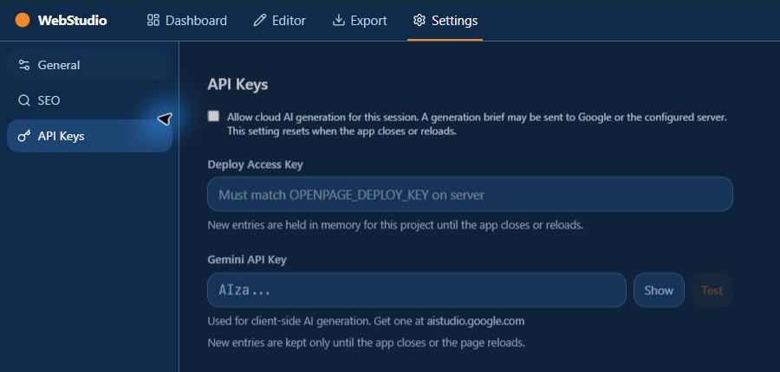
Figure 13. API Keys settings: new credentials and cloud consent are session-only.
Settings > SEO provides Page Title, Meta Description, optional Public site URL and OG Image URL, plus a search-result-style preview. The public URL affects generated canonical addresses and sitemap; if the site will live under a subfolder, include that subfolder. The preview is illustrative and cannot guarantee a search engine's display.
Settings > API Keys contains the optional Gemini API Key and a deploy access-key field. New entries are held only for the current application session. The cloud-generation consent checkbox also resets on close or reload. Older saved values may remain in local storage or settings and can be removed with the controls shown. Avoid sharing keys or placing them in site text, screenshots or exported files.

Reference Local AI and cloud AI
Local AI is optional. Open a project and choose the native Local AI menu. The dialog supplies download links for the supported llama.cpp runtime ZIP and supported GGUF models; download them separately, then browse to the actual ZIP and model file. The 1.7B model is about 1.8 GB and the offered 4B model about 2.5 GB. The offered runtime is Windows x64. Adequate disk space and memory are necessary, and actual speed varies by computer.
Choose the proposal type, describe the request in the supported length, and choose Generate. Five-page generation requires a blank project; supported follow-up choices include a single page and theme colors. The app checks pinned files and runs the local model in a supervised local process. Review generated page names, headlines and proposed colors before accepting. Changes can be undone as a group. Generated statements may be wrong or invented; verify them against the source information.
Cloud generation is distinct from choosing a local starter and from local AI. In Settings > API Keys, entering a Gemini key and opting into cloud use permits the relevant generation brief to be sent to the configured online service for that session. The application tests a key through Google's models endpoint when Test is used. Test success does not establish that all models, billing arrangements or quotas are available. New keys and the opt-in are not retained after close or reload.

Reference File formats, backup and revisions
Open project accepts supported original OpenPage JSON, versioned WebStudio JSON and WebStudio project ZIPs. A selected source is opened as an independent draft, not silently overwritten. A new project ZIP contains a manifest and project media. The raw JSON Config download exposed by the export page is not the same as a complete project ZIP and can omit media or contain private settings.
Choose Save project to write an editable project file. The desktop uses a destination dialog and staged file. Replacing an existing target requires a separate confirmation and a verified recovery ZIP; the operation has size and filesystem limits. Keep independent copies because interruption, power loss and all filesystem behaviors are not fully proven.
Create local revision stores a local snapshot of the current project and media. Open a revision as a separate project for inspection, or choose Save revision as file to keep a separate copy. New revisions include a checksum. Older snapshots may lack one and should be opened and verified. Removing a local revision requires confirmation and cannot be undone; removing a local project does not automatically remove its revisions.
Project > Back up project creates a checked backup ZIP of a selected saved project. Project > Restore project backup writes a restored copy under a new name; open and check it. Current documented limits are 512 MiB for a project and 513 MiB for a backup archive. Recover staged file handles a retained temporary download in the same folder and performs only preliminary format recognition; the result might be incomplete.

Reference Import limits and retained source
Static HTML import accepts a selected folder of up to 1000 files and 100 HTML pages, with a combined maximum of 1 MiB of UTF-8 HTML and CSS, and up to 200 supported images totaling at most 100 MiB. The report identifies skipped files, issues and recognized reference problems. Some report details are capped at 100; inspect the original files as well.
The importer can convert basic text, headings, lists, emphasis, recognized local images and links. It does not reconstruct arbitrary styling, scripts or layout. Unconverted page source may be retained in a read-only inert block excluded from export. Original HTML and CSS can be retained as inactive project data. Review every imported page, save a new project and keep the original folder.
WordPress import accepts a UTF-8 WXR XML export up to 1 MiB and 500 items. XML document-type and entity declarations are rejected. Posts and pages become editable content with limitations; posts and unpublished pages start as drafts. Images, attachments, themes, plugins, shortcodes and server behavior are not fully recreated. The original XML and conversion report may be retained in the project and can contain private data.

Reference Review and export
The editor Export button prepares a website ZIP. The Export page can also prepare a local file review, download the reviewed ZIP, create a manifest, compare an earlier manifest or destination scan, and review a restore plan with a matching backup. These operations are local reviews; they do not by themselves upload files. If the project changes after preparation, review again.
Extract a website ZIP to a separate test folder. Check each page, internal link and referenced asset. Some PDF viewer modules will not run correctly from a direct file address because browser restrictions apply; use a local web server for the extracted site. External media and optional integrations can still require an internet connection.
The native SFTP connection form uses host, port, username, a private key and a trusted-hosts file. Test connection, destination scan, backup and review are separate operations. Publishing requires an explicit additional action and confirmation. The recorded transfer and rollback tests used synthetic loopback data; do not assume every host has been verified. A real website is not created or published by the workflow in this guide.

Reference Keyboard controls
The application's shortcut dialog lists 1 through 5 for Dashboard, Editor, Components, Deploy and Settings; J toggles JSON, H history, P preview, Escape deselects a block or closes applicable dialogs, and question mark opens the shortcut help. The displayed undo and redo shortcuts depend on the environment; use the toolbar controls if a shortcut does not work as expected. Avoid invoking navigation keys while entering text.

Reference Known boundaries
The app is experimental. A clean Windows installation and real-host publication remain unverified. The user requested no website publication during this work. Project recovery tests cover selected scenarios and cannot prove immunity to power loss, storage failure or all possible data loss. Always keep separate copies.
The static and WordPress importers are partial conversions. Full professional editing of generated HTML and CSS, all CMS features, complete accessibility auditing, full preview/export parity and all optional model or dependency redistribution terms remain unverified or unfinished. A website exported from this app is not guaranteed to work unchanged on every host or reproduce a proprietary website.

